From 1 April 2017, non-emergency patient transport will be provided by E-zec Medical Transport Services.
The patient transport service (PTS) provides planned, non-emergency transport for eligible Bristol, North Somerset and South Gloucestershire patients to and from NHS hospitals and clinics, including outpatient departments, inter-hospital transfers, renal dialysis, oncology centres and your home.
It is only available for eligible patients for medical reasons (see overleaf).
It is not available for trips to primary care services such as GP practices and is not part of the emergency ambulance service.

Patient transport vehicles are staffed by ambulance care assistants (ACAs) who ensure your medical needs are met throughout the journey and during transfer.
E-zec Medical working with the NHS

What do I need to do? Patient Transport Services
If you have already made a booking you don’t need

to do anything as all the bookings will be automatically transferred to E-zec.
New bookings can be made on the number below from 13 March 2017.

Ambulance transportation delivering you to your
hospital appointment from 1 April 2017

Booking Office and enquiries
T: 0300 777 6688

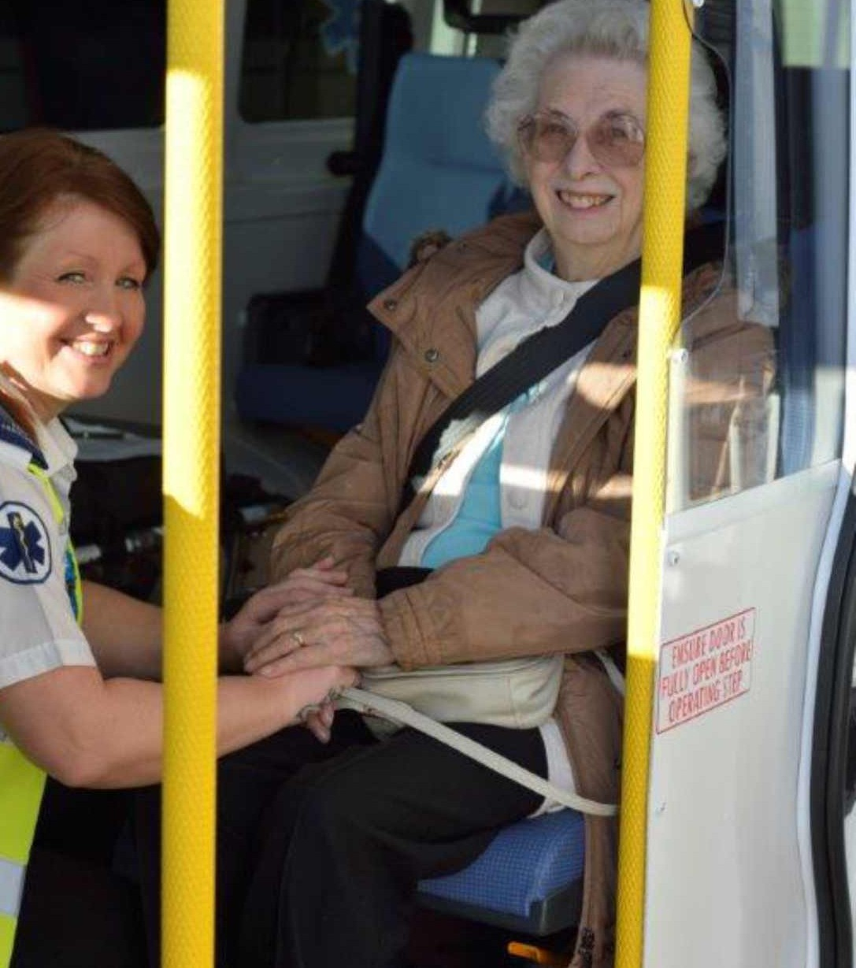
Am I eligible for patient transport?
You are eligible for patient transport if:
• Your medical condition means you cannot use other transport without damaging your health
• Your mobility means you are unable to access healthcare by any other means
• You need the skills or support of clinically trained staff and / or medical equipment during your journey
Transport could also be provided to a patient’s escort or carer where their particular skills and/or support are needed. This may be appropriate in the case of accompanying a person with a physical or mental incapacity, a vulnerable adult, or in the case of patients needing a translator. This would need to be agreed for each individual case at the time of booking the transport.

Patient escorts
The Patient Transport Service provides skilled and qualified staff who will in most cases fully meet the patient’s needs during their journey.
Escorts take up a valuable seat on patient transport vehicles, which could be used for other patients. Escorts are restricted to one per patient under the escort eligibility criteria opposite and who must themselves be fit to travel unassisted.
All escorts who do not meet the escort eligibility criteria are welcome to meet the patient at the hospital.

Patient escort eligibility criteria
- The patient is a minor (under 16 years of age). The escort must be a responsible adult
- Recognised as a parent or guardian where children are being transported
- The patient has a psychiatric or learning difficulty and/or needs constant supervision during the journey and/or within the hospital
- Professional escort from ward/nursing or residential home
- Patient with special needs e.g. the patient is blind, confused, hard of hearing, speech or language difficulties
- Patients who may require assistance prior to and/or following their appointment

